

High Frequency Electromagnetic Software

Contact Us | Site Map
- Home
- About Sonnet
  - The Company
  - Employment
  - Events
  - Partners
  - Contact
- Products
  - Sonnet Suites (3D Planar)
  - CST STUDIO SUITE (Full 3D)
  - Sonnet Lite (Free 3D Planar)
  - Which should I choose?
- Support
  - Sonnet Suites
  - CST STUDIO SUITE
  - Sonnet Lite
- Resources
  - Technical Resources
  - Training Classes
  - Videos
  - Journal References: Sonnet
  - Journal References: Customers
  - JC Maxwell Biography

Products
- Sonnet Suites
- CST STUDIO SUITE
- Sonnet Lite
  - Free Download
  - Applications
  - FAQ
  - New Features
  - Detailed Features
- Which product should I choose?

Related Links
- Demo Videos
- Training Courses
- Upgrade Paths
- System Requirements
- Support
Home > Products > Sonnet Lite > 2-Turn Spiral Inductor with Air-Bridge

2-Turn Spiral Inductor with Air-Bridge
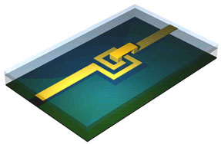 |   Download this example

Above: This example shows a 1.5-turn microstrip series-configuration spiral inductor on undoped silicon (er = 10.2). Width and spacing of the inductor are both 10 mils. An air bridge with a height of 2 mils connects the center tap to the output microstrip line.
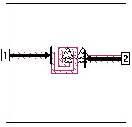Layout of the circuit feed lines and spiral on the lower level in the project editor, sitting on a 10 mil Si substrate with ground plane below. Upward-pointing triangles indicate vertical vias going up from this layer. Dark arrows indicate reference planes for automatic de-embedding of the port discontinuities and connecting feed lines. The two vias support the metal bridge in air, on the layer above (not pictured).
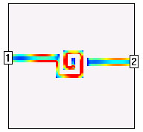Surface current density (Jxy) on the spiral inductor at 10 GHz. Red indicates high current density, blue is low. Current density shown is displayed by the current density viewer in Sonnet Lite.
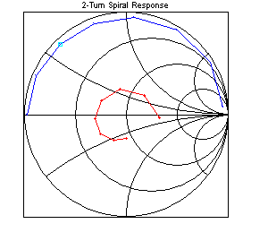Response viewer display of Sonnet Lite output data. S11 (input return loss) is shown in the red graph, S21 (through parameter) is shown in the blue graph. Both traces move clockwise with rising frequency; data shown is 8-15 GHz.
This analysis required 1 Mbyte at the highest frequency of 15 GHz. This simulation may be performed using the Unregistered version of Sonnet® Lite. All results and graphics shown above were created using Sonnet Lite.
Privacy Policy | Site Problems?
Copyright © 2009 Sonnet Software Inc. All Rights Reserved.

